**Practical no.-**21

**Title:** Develop a program to implement broadcast receiver.

**Roll No.:**15 **Batch-** A **Date of Performance:** 04/03/2024

**activity_main.xml**

<?xml version="1.0" encoding="utf-8"?>

<AbsoluteLayout xmlns:android="http://schemas.android.com/apk/res/android" xmlns:app="http://schemas.android.com/apk/res-auto"

xmlns:tools="http://schemas.android.com/tools"

android:layout_width="match_parent"

android:layout_height="match_parent"

tools:context=".MainActivity">

<TextView

android:id="@+id/tv"

android:layout_width="259dp"

android:layout_height="40dp"

android:layout_x="15dp"

android:layout_y="233dp"

android:text="Battery Status="

android:textSize="25dp" />

</AbsoluteLayout>

**BatteryChange.java**

package com.example.pract_21broadcast;

import android.content.BroadcastReceiver;

import android.content.Context;

import android.content.Intent;

import android.widget.TextView;

public class BatteryChange extends BroadcastReceiver {

TextView tv;

public BatteryChange(TextView tv)

{

this.tv=tv;

}

@Override

public void onReceive(Context context, Intent intent) {

int Percent=intent.getIntExtra("level",0);

if(Percent!=0)

{

tv.setText("Battery Status="+Percent+"%");

}

}

}

**MainActivity.java**

package com.example.pract_21batterychange;

import androidx.appcompat.app.AppCompatActivity;

import android.content.*;

import android.os.Bundle;

import android.widget.TextView;

import com.example.pract_21broadcast.BatteryChange;

public class MainActivity extends AppCompatActivity {

TextView tv;

BatteryChange bc;

protected void onCreate(Bundle savedInstanceState) {

super.onCreate(savedInstanceState);

setContentView(R.layout.activity_main);

tv=(TextView) findViewById(R.id.tv);

bc=new BatteryChange(tv);

IntentFilter intentFilter=new IntentFilter(Intent.ACTION_BATTERY_CHANGED);

registerReceiver(bc,intentFilter);

}

@Override

protected void onStop() {

super.onStop();

unregisterReceiver(bc);

}

}

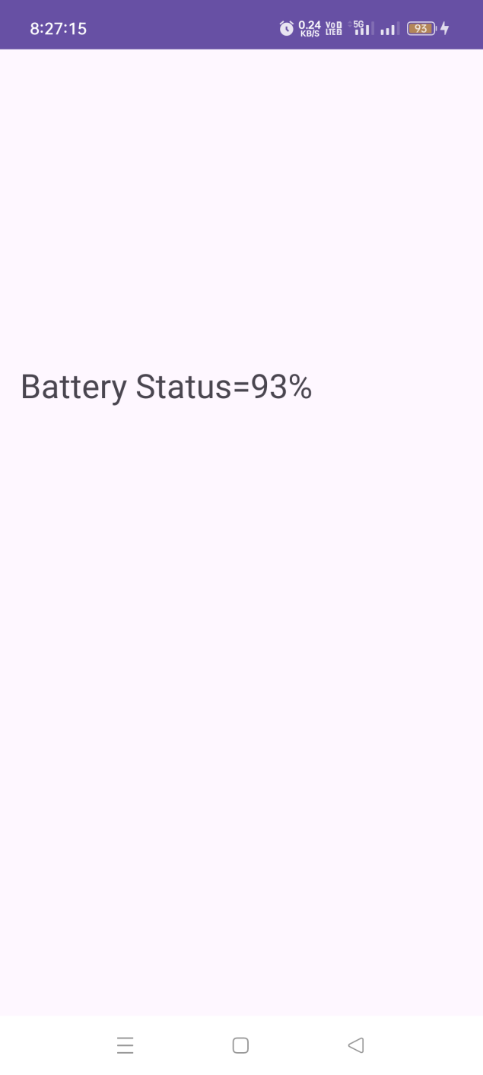

**activity_main.xml**

<?xml version="1.0" encoding="utf-8"?>

<AbsoluteLayout xmlns:android="http://schemas.android.com/apk/res/android"

xmlns:app="http://schemas.android.com/apk/res-auto"

xmlns:tools="http://schemas.android.com/tools"

android:layout_width="match_parent"

android:layout_height="match_parent"

tools:context=".MainActivity">

<TextView

android:id="@+id/tv"

android:layout_width="411dp"

android:layout_height="84dp"

android:layout_x="15dp"

android:layout_y="233dp"

android:text="Aeroplane Mode State"

android:textSize="25dp" />

</AbsoluteLayout>

**Aeroplanemode.java**

package com.example.pract_21broadcastreceiver;

import android.content.BroadcastReceiver;

import android.content.Context;

import android.content.Intent;

import android.widget.TextView;

public class Aeroplanemode extends BroadcastReceiver {

TextView tv;

public Aeroplanemode(TextView tv) {

this.tv = tv;

}

@Override

public void onReceive(Context context, Intent intent) {

boolean status = intent.getBooleanExtra("state", true);

if (status) {

tv.setText("Aeroplane Mode turned on");

} else {

tv.setText("Aeroplane Mode turned off");

}

}

}

**MainActivity.java**

package com.example.pract_21broadcastreceiver;

import androidx.appcompat.app.AppCompatActivity;

import android.content.*;

import android.os.Bundle;

import android.widget.*;

public class MainActivity extends AppCompatActivity {

TextView tv;

Aeroplanemode av;

@Override

protected void onCreate(Bundle savedInstanceState) {

super.onCreate(savedInstanceState);

setContentView(R.layout.activity_main);

tv = findViewById(R.id.tv);

av = new Aeroplanemode(tv);

IntentFilter intentFilter = new IntentFilter(Intent.ACTION_AIRPLANE_MODE_CHANGED);

registerReceiver(av, intentFilter);

}

@Override

protected void onStop() {

super.onStop();

unregisterReceiver(av);

}

}

